Milestone 1 Project launch and research
I will first construct the <theory-of-the-program>, then generate <program text> only after the theory is explicit.

OPERATIONAL_DIAGNOSTIC
Substantives_Demolished Replace vague uses of experience, aesthetic and scope with the actions and records below.
Occult_States_Removed Replace a claim that players will feel tension with a visible choice, a displayed consequence and a stated ending.
The_Language_Game Both partners select one concept by comparing its actions, required assets and reachable outcome.

CONTROL_SURFACE_DRAFT
Compare three different interactions, select one with your partner, and submit a sketch that shows its controls and response.
Start with Bring the assignment, access to WarGames, reference links, any March 18 lab sketch, and both partners' available work time. Record missing inputs before beginning.
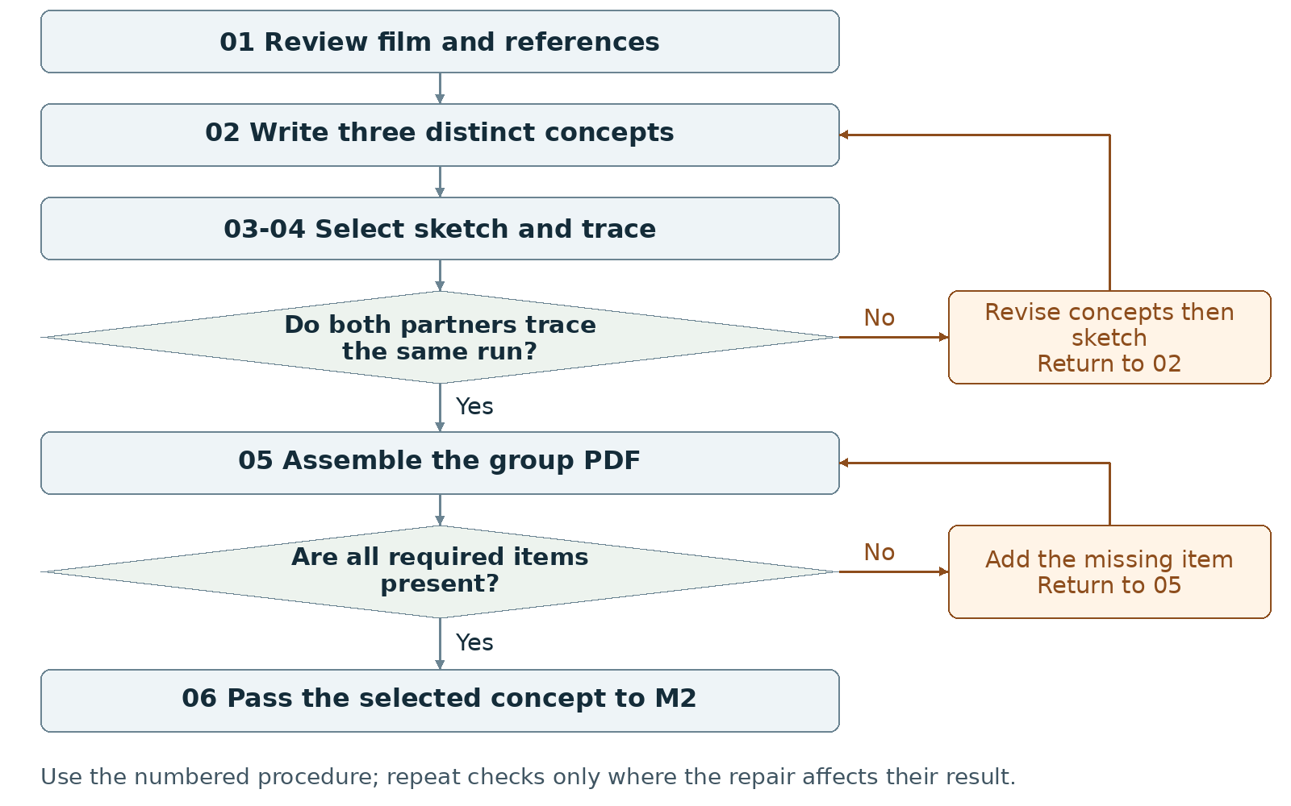
Required package Submit one group PDF of at least two pages.
Assign maker __________ and checker __________. Swap roles at the next task. Leave checks pending until performed.

Milestone 1 Write the rules

1 <Initial Interpretation>
Write one proposed sequence per concept: <player> [uses] <control>; <program> [checks] <condition>, [updates] <value> and [shows] <response>. Name the activity represented and the ending test the program checks. Mark every operation as planned until code exists.

2 <Theory Skeleton>
Record | What to write
<Entities> | Name the player, information displayed, choice offered, consequence and outcome for each concept.
[Operations] | Name one central action per concept. Record the visible response to that action.
<States> | Sketch a proposed start, interaction and outcome. Mark these as planned screens or states.
<Conditions> | Write when the player may act and what event reaches an ending.
<Invariants> | Propose a rule that remains true throughout a named scope. Example to adopt or replace: during a run, the active-state value always belongs to the declared state IDs.
<Constraints> | List required platform, two-person work, available sessions and assets. Mark optional features for removal if they displace required work.
Use conditions to decide whether an action or transition is allowed. State the scope of each invariant and how to check it. Keep submission requirements separate from runtime rules.

3 <Assumption Ledger>
Status | Action
<safe> | Enter an unverified premise only with its basis and limited consequence if wrong. Keep cited assignment requirements in the constraints record.
<uncertain> | Record untested controls, session length and asset effort. Assign a sketch, walkthrough or setup check to each uncertainty.
<requires-user-decision> | Leave the selected concept and final input method open until both partners record their choice.
For each open item, record {claim, status, person checking, evidence to collect, next action}. Keep a proposed choice labeled proposed until the group adopts it.
Record the next open item Claim __________ Status __________
Owner __________ Evidence/check __________ Next action __________
Write <entity> for a person, object, value or state; [operation] for an action; and {record} for related fields. Record planned, observed, failed or not tested beside each claim. Do not mark a check passed until a person performs it and records the result.

Milestone 1 Run the procedure

4 <Operational Description>
Read each action aloud before doing it. The maker performs the action; the checker records the named result. Use the return instruction when a check fails.
Step | Perform and save | Check and return
01 Collect observations | Revisit the film; record a source location and observation. Collect credited visual references. Review relevant supplied tutorials. Open or install Processing with p5.js mode and run a minimal setup check; record blockers. Organize references and sketches. | The partner locates each reference. Replace unsupported film claims. Record setup separately from the static sketch; a working game is not required here.
02 Draft three concepts | Each partner contributes. Write one paragraph per concept covering the action sequence, visual treatment and player/interactor outcome. Change the central action between concepts; three color schemes do not make three concepts. | Underline the action and ending in each paragraph. Rewrite any pair that asks the player to do the same thing in the same way.
03 Select and sketch | Compare required screens, assets and build work. Record the selected concept and one rationale paragraph explaining the choice and its effect on the final project. Draw a title, main or other interface with controls and feedback. | Both partners write the selected name and point to the control and its response. Reopen the choice if the selection is still disputed.
04 Trace the sketch | Give both partners the same starting screen and action. Each writes the next display and ending rule, then compare records. Label the sketch static if it is not executable. | Resolve every conflicting prediction in the concept paragraph or sketch. Do not claim the program works from a static image.
05 Assemble and inspect | Export one PDF with the three concepts, selection paragraph, sketch, screenshot/capture, references, progress note and AI statement. Open the exported PDF and check page count and readable labels. | Use at least two pages. Add missing content or enlarge unreadable text, export again, and reopen the PDF.
06 Hand off | Place the selected concept, sketch, references, open decisions and AI record with the M2 inputs. Both partners open the same files. | Record the submitted file name and any unresolved question. Begin M2 from the selected concept only.

5 <Failure Description>
Observed problem | Required response
No distinct concepts | Rewrite the central action or outcome in step 02; keep three different proposals.
No adopted selection | Compare work and constraints in step 03; keep the stage pending until the group records its choice.
Polished image with no usable control | Add the control, feedback and ending reference in step 03; repeat the trace in step 04.
Use the map A no branch returns to the named task. Repair the recorded problem and repeat that check; do not mark the stage passed because the planned time window ended.

Milestone 1 Test changes and produce the work

6 <Change Test>
Ask: "What would change if the requirements changed?" The maker writes the expected result first. The checker performs or traces the change and records the result. Swap roles for the second scenario.
Modification | Run this check
Replace the input | Replace typed commands with visible buttons, or reverse that choice. Redraw the control and trace the same decision. Record which rules remain unchanged and which instructions change.
Reduce the work budget | Halve the proposed session length and custom-asset allowance. Cross out optional content. Verify that the central action, a reachable outcome and all required deliverables remain.
Save {version or design record, starting condition, input/change, expected result, observed result, pass/fail/not tested, next action}. Use paper traces in M1-M2; report executed checks only when they occurred.

7 <Implementation Plan>
Assign reference collection and first concept drafts to one partner; assign the comparison sheet and first sketch to the other. Swap review roles before selection. Run only a small setup or behavior experiment if it answers a named uncertainty.

8 <Program Text>
Produce the concept paragraphs and interface sketch. Do not build the full project at this stage. If a small executable proof is used, write its rule and expected output first, then record what the run actually showed.

9 <Theory-Code Mapping>
Element | Record the connection
<types> | List proposed data such as choice or signal; do not claim it is implemented.
<functions> | Map the central action to a proposed operation.
<classes> | Use none unless a later design gives one a specific responsibility.
<tests> | Keep the two partners' sketch traces and change-test notes.
<comments> | Annotate why the sketch puts a control or display in that position.
<configuration> | Record proposed controls, session length, colors and asset allowance.
Use actual file and function names when code exists. Label planned counterparts proposed; write not applicable when a structure is absent.

Carry forward the course rules
Keep the project connected to WarGames. Build in Processing using p5.js mode; accept interactive input; include at least three distinct screens or states; provide a start and reachable outcome; credit external material; organize and comment the code.
Record actual AI use at every milestone, including use of this manual if adopted. Use AI for bounded brainstorming, explanation, small examples you study and adapt, specific debugging or review. Author the project as a group; do not request an entire generated project. Identify assisted code and your changes in comments.

Milestone 1 Submit and hand off

10 <Residual Human Theory>
Record the reason for choosing this concept, the alternatives rejected, and one question still needing a running test. Each partner points to a reference and to the sketch element it influenced. Preserve disagreements as open decisions.

Check the required submission
- One group PDF, at least two pages.
- Three concept paragraphs covering experience, aesthetic and interactor/player outcomes.
- One selected-concept paragraph explaining the choice and its influence on the final project.
- One proof-of-concept interface sketch; label a static mockup as static.
- At least one screenshot or sketch capture, a short progress note, reference credits and an AI Use Statement.
Suggested PDF order: concepts and selection on page 1; sketch, captions and records on page 2 or later. Add pages when needed for readable text.
Completion check The checker finds every required item in the exported PDF. Both partners identify the same selected concept and trace one action from the sketch to its response and proposed ending.
Progress note Name the current version; state what was completed and checked, what is missing, and the next action with its owner. Add the screenshot/capture supporting the current status.

Complete the AI Use Statement
Field | Enter the actual record
Tool and dates | Name the tool, or record no AI used only if accurate. Enter actual dates of use.
Request and affected work | Summarize the request. Name the text, image, planning record or code file affected.
Kept changed rejected | Record the output retained, edits or rewrites made, and material discarded.
Group confirmation | Recommended check: each partner traces actual submitted code; for planning-only work, trace the proposed interaction. Identify image sources, retained edits and displayed information. Then complete the required group confirmation covering code and images; leave it pending until both partners can confirm it.
If this AI-produced manual is adopted, record ChatGPT, October 21 2026, milestone planning and operational rewrite, and your actual kept/changed/rejected choices. Do not copy a completed student confirmation from this manual.
Handoff Send the selected concept, rationale, sketch, source list and open decisions into M2. Do not carry the rejected concepts forward as simultaneous requirements.
Record: maker __________ checker __________ version __________
Checks still pending __________ submitted file(s) __________ upload status __________
Requirements source: supplied WarGames project brief and milestone instructions. Treat roles, file names, internal checks and relative-week allocations as recommended working procedures. Use corrected deadlines from the course; none are asserted here.

